IVAI Summer Program NYC

Ko te manu e kai ana I te miro, nona te ngahere engari, ko te manu e kai ana I te matauranga, nona te ao. (The bird who eats from the Miro tree, owns the forest but, the bird who eats of the tree of knowledge will gain the world)

## Day One

What a beautiful city! I arrived into New York after nineteen hours of travel time and two delays. I am truly thankful to the Lord that I have arrived safely. I caught a shuttle bus to my apartment in New York and it is absolutely perfect. I am sharing this apartment with another participant of the IVAI Summer Program from Montreal, Canada.

Today, those who were given roles in the school productions were invited to attend a rehearsal even though the actual program starts tomorrow. It was amazing to meet some of the other students who were given roles in the opera production for this program. I was offered the role “Schaunard” in Leoncavallo’s La Boheme. Our rehearsal today was taken by the internationally renowned conductor Lucy Arner. I was in awe when I read the list of the great singers whom she had conducted before like, Joan Sutherland, Placido Domingo and Luciano Pavarotti. You can tell just by the way she conducts and the advice that she gave today that she is a super intelligent woman who has a passion for opera to match. Lucy gave some very useful advice for me today to help with my language in my higher register. I look forward to learning more from Lucy with the advice that she gives me and also to the other singers. I feel like I am a dry sponge who has been dropped in puddle of knowledge from experience.

Today while shopping, I also met an amazing Samoan lady who was an Olympian for American Samoa and is now a track and field coach at the University of Connecticut. She is also now a motivational speaker and she spoke nothing but words of encouragement, motivation and life into me. She gave me some advice today that will continue to inspire me in my career and my everyday living. My last words for my journal today will be the quote that she said to encourage me as a student, to be inquisitive, to ask questions and to never be shy to ask for things that you need to further my career.

“A closed mouth never gets fed”

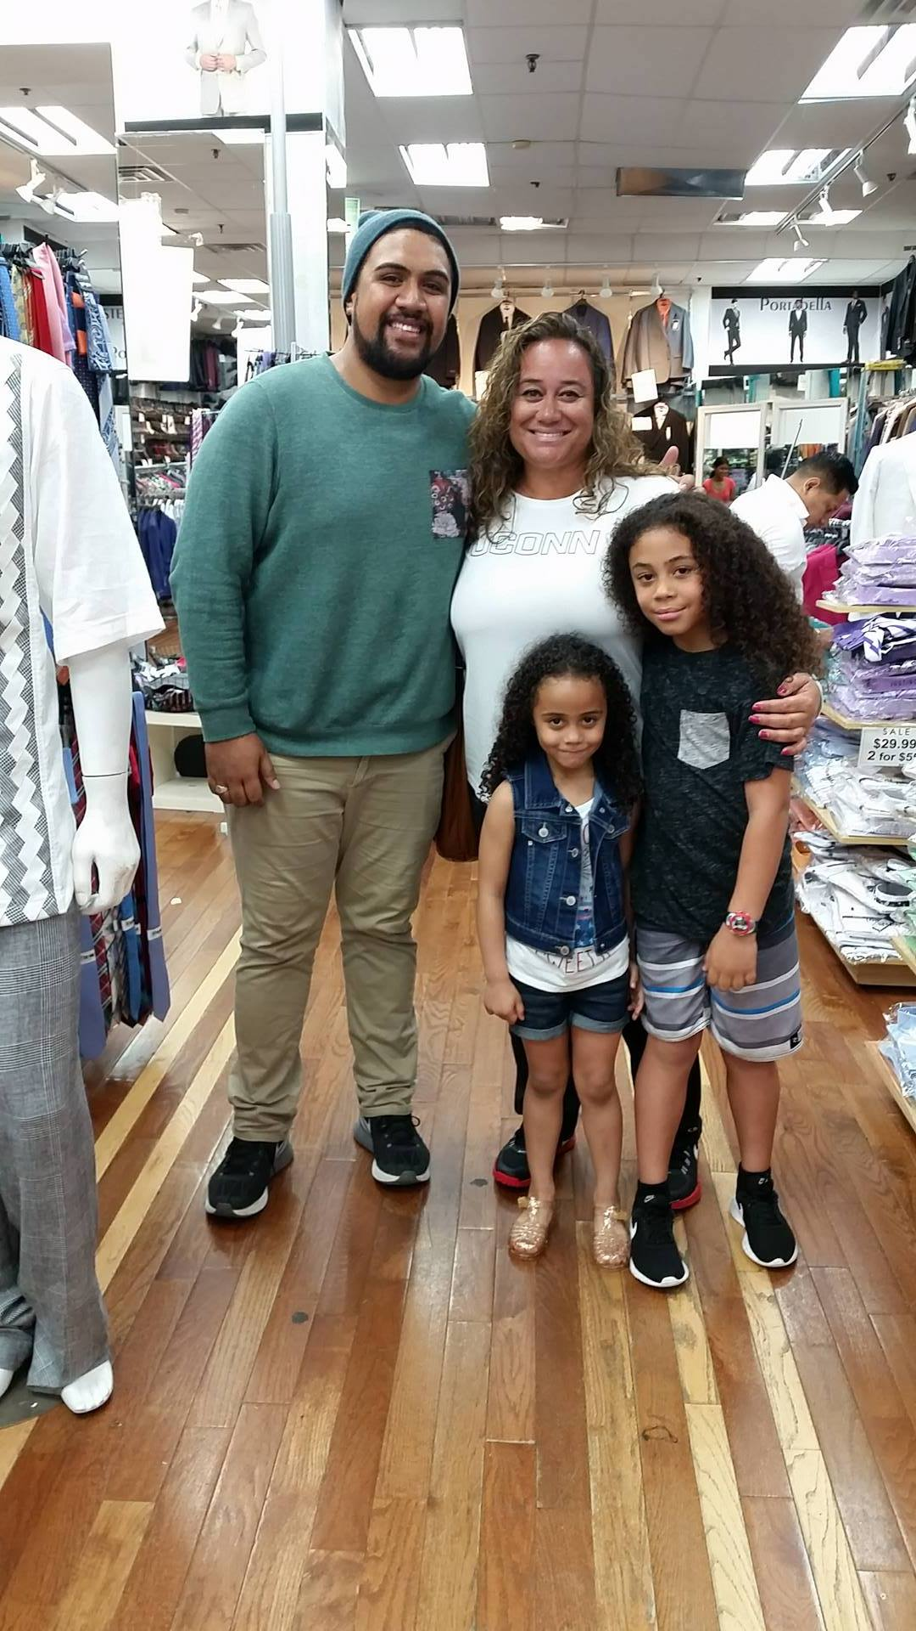

**A picture of Lisa Misipeka, her kids and myself in the suit shop that we met in.**

## Day 2

So today we had a little two minute introduction performances for all of the students. We all had to stand up and sing a 2 min excerpt from any of the repertoire that we had bought to work on. I was no.3 and was anxious to perform, but as soon as I got on stage my anxiety transformed into energy and I was able to perform my 2 minute excerpt from “Mein sehnen, mein wahnen” by Korngold.

Unfortunately, as soon as I had finished singing, I had to rush off to my Boheme rehearsal. Although I didn’t get to hear the other students sing I know that I will hear all of them eventually over the next three weeks. Rehearsal was very intense and I couldn’t believe that we were going straight into staging but I managed to stay on top of the rehearsal. I am excited to be working along singers who are from around the world.

Today I also met Joshua Major who will be directing our opera. Joshua seems to be quite a humble guy who really works with us artists to make sure that the interpretation we have in mind is clear. I am really enjoying working with Joshua Major and Lucy Arner!

My quote of the day has to come from Lucy:

(In regards to rubato) “If you steal from Peter, pay back Paul!”

## Week 2 – La Boheme

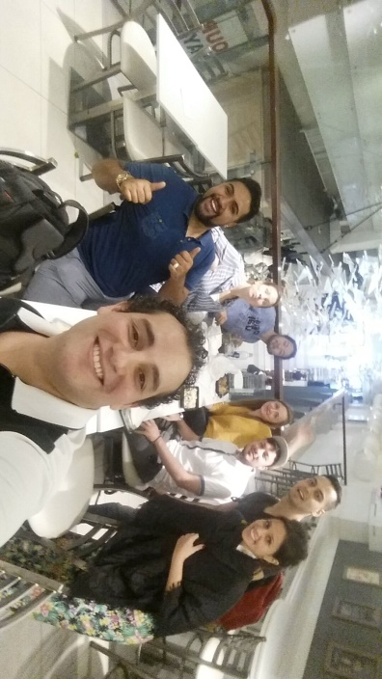Today we had rehearsal from 10:30am to 6pm, with breaks in between of course, and I was extremely drained but at the same time extremely happy with the progress we have made with the opera. The chemistry of the cast is also picking up quite rapidly. Although we are from different countries, we still get along really well and can joke around together. We all had lunch together and it was heaps of fun. These rehearsals are an excellent opportunity for young singers like me to learn to use our energy efficiently and to learn how to rest at any given opportunity.

Here is a photo of all of us cast at lunch! From L-R Myself (NZ), Caroline (Canada), Hide (Japan), Benito (Mexico), Antonina (Ukraine), Ivan (Serbia), Omar (Mexico) and our new friend we just met at lunch from Brazil.

## 

## Week 2 – Coaching with Rosemary Landry

This week I have been in absolute awe at the level of coaching and tutelage that I have been receiving here at the IVAI Summer Programme NYC. I have been blessed to be able to work with Rosemary Landry who is an internationally renowned opera singer as well as a French repertoire specialist. This week I took my French art songs for her to work on and she has given me invaluable advice on how to approach these pieces as well as how to pronounce the words.

## Week 2 – International Song Concert

This week I have also been honoured to be able to perform for the International Art Song concert. Let’s just say that I was incredibly blessed to be able to share the Maori culture with the audience at this concert. I have heard so much great feedback about how the Maori “wiri” (quivering of the hands) is such a powerful gesture when performing Maori songs. It was also a great honour to sing alongside my fellow Kiwi Emily Mwila for this evening. We were privileged to be able to share the Maori culture abroad.

## Week 3 – Coaching with Hemdi Kfir

This week I have been blessed to be able to get coaching from the diction coach of the Metropolitan Opera House NYC. We have been focussing on really polishing my language in my German and Italian arias. I feel so blessed and privileged to have been able to work with such an amazing coach who has such passion and love for the expression of opera through the language.

## Week 3 – La Boheme Performance

 It is now the big performance day for the La Boheme that we have been rehearsing over the last 3 weeks. I am really excited and I can’t wait to hit the stage with my first few lines as I am in the first scene that starts off the opera. Once again I can’t help but think how blessed I am to be chosen out of the 70+ participants of the IVAI Summer Programme to do one of the main roles in their production. It has been an absolute pleasure to share the stage with some of the worlds up and rising opera stars. It has also been amazing to be gifted with such pearls of knowledge from our conductor Lucy Arner and Joshua Major our director.

Both of these names have had and still have amazing careers. Lucy has worked with many famous opera singers and has conducted some of the greatest opera singers we know today. Joshua Major has really helped me to zone in on my acting and from day one has pointed out my weaknesses in stagecraft and has really equipped me with the right tools to tackle these weaknesses and perform to my best ability. I will never forget his words “Think of the beat” and “Schaunard mustn’t be angry, BENSON must be angry.”

I really look forward to tonight’s performance and I can’t wait to be on stage! To the left is a photo of myself and Joshua Major.

## La Finale!!

Tonight I performed in the final concert at the IVAI Summer Programme and I can’t believe how fast these three weeks have gone. I also can’t believe the amount of growing I have undergone. I leave the IVAI Summer Programme feeling equipped with the right tools that an emerging opera singer needs as a foundation for a great career. I think back also to all of those who have helped me get here today and I cannot express the gratitude I have for all of the love I have been shown through financial support, moral support and spiritual support.

Without the financial funds, I wouldn’t be able to have this invaluable opportunity and this dream would never have become a reality. I especially would like to thank the IFAC Australian Singing Competition and the Judith Clarke Memorial Foundation for the remarkable financial support you have ever so kindly gifted me. Thank you for believing in me, a young aspiring opera singer, and I do believe that your support has given me the boost that I needed to build a solid foundation for my career.

Thank you to the team at the IFAC Australian Singing Competition, especially Amelia Gledhill for organising this opportunity for young singers of Australasia!

IVAI Summer Programme NYC – DONE!   
With much love,   
Baritone Benson Wilson

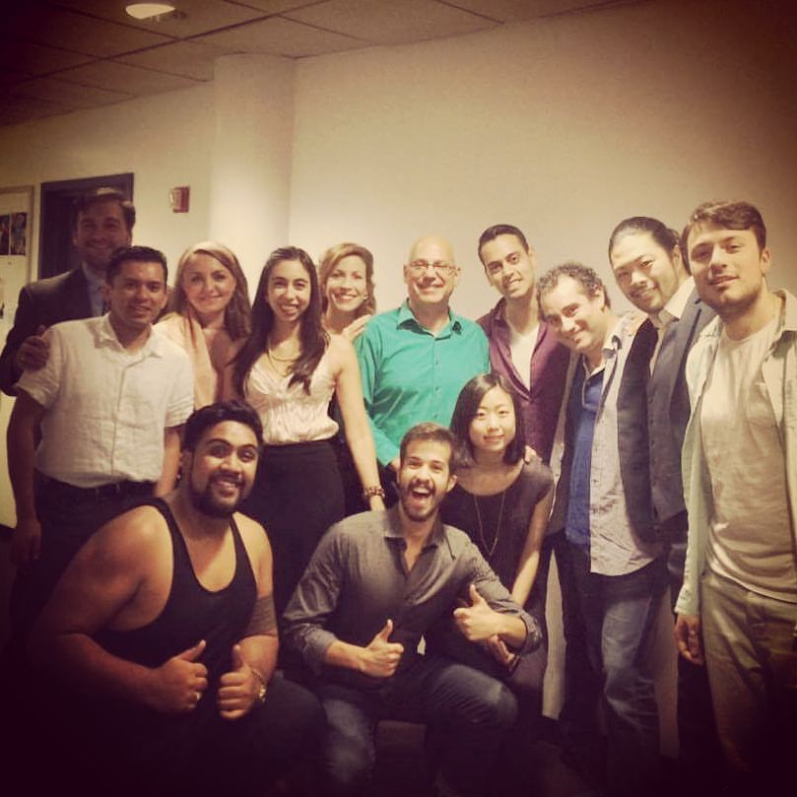

The cast and director of Leoncavallo’s La Boheme performed at the IVAI Summer Programme 2016.